INFORMATION DOCUMENT
regarding built-up real-estate covering 514 916 m² by the quays Helskie I, Helskie II and Oksywskie Quay, the area of the streets Kontenerowa, Logistyczna and Kwiatkowskiego linked with the real-estates in the hinterland of Port Gdynia in the area of the ‘Logistic Valley’.

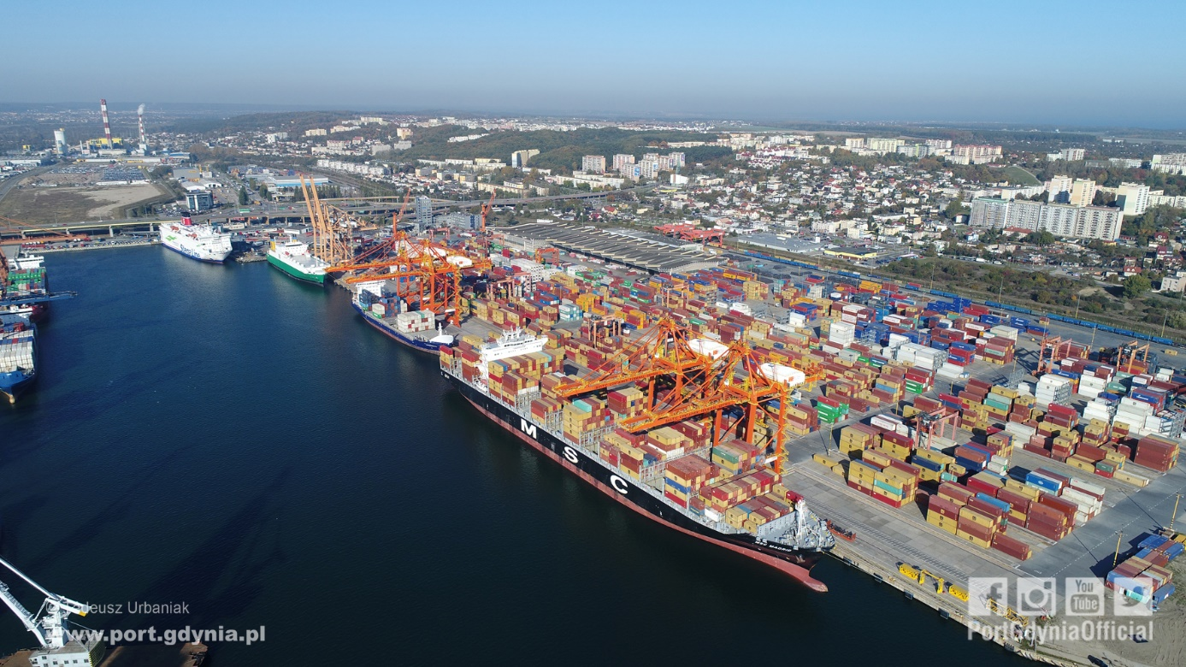

- Gdynia, May 2019
Contents
- Introduction
- Application of the Real-Estate and Contract Director ref. ZNN-U/DIAL/491/JK/2019 dated 20.05.2019 to the Management Board of the Company ZMPG S.A. to conduct a technical dialogue.
- Real-estate location and transport connections
- Real-estate location
- Transport connections
- Description of the real-estate
- State of the real-estate
  - Built-up
  - Other information about the real-estate and its facilities
  - Utilities and telecommunication
- Environmental protection
- Operational information and period of use
    - Operational assumptions for the real-estate in terms of seaport turnover
    - Expected shipside cargo handling volume
    - Period of lease
- Relation to neighbouring ZMPG S.A. investment areas and neighbouring area of the Logistic Valley
- Investment areas adjacent to the real-estate
- Logistic Valley area
- Other information
Projected construction of External Port
- Introduction
- Application of the Real Estate and Contract Director
The Information Document has been prepared in connection with performance of the Application of the Real-Estate and Contract Director Ref ZNN-U/233/DIAL/491/JK/2019 dated 20.05.2019 to the Management Board of the Company Zarząd Morskiego Portu Gdynia SA (ZMPG S.A.) regarding a technical dialogue of the Company to specify the future real-estate lease terms and conditions covering an area of 514 916 m² by the quays Helskie I, Helskie II and Oksywskie Quay, the area of the streets Kontenerowa, Logistyczna and Kwiatkowskiego leased by BCT Baltic Container Terminal sp. z o.o. seated in Gdynia, up to 31.05.2023, linked with the real-estates in the hinterland of Port Gdynia in the ‘Logistic Valley’ located in Gmina Kosakowo.

- Real-estate location and transport connections
- Real-estate location
The real-estate for rent covering in total an area of 514 916 m² is located in the western area of the port in Gdynia by the streets Kwiatkowskiego, Kontenerowa and Logistyczna.
The real-estates referred to above are covered by a local spatial development plan of the region Western Port in Gdynia, adopted in the Resolution no IV/46/07 Gdynia City Council dated 24 January 2007.
A map of the real-estate for lease is appended as Annex no 1 to this Information Document.
- Transport connections
The real-estate is located by the streets Kwiatkowskiego, Kontenerowa and Logistyczna in Gdynia, leads through the street Wiśniewskiego and Kwiatkowski Estacada linked with the TriCity ring road and the network of national roads, including A1, S6, S7.
The real-estate has direct access to Helskie quay, generally accessible railway siding and the streets Kwiatkowskiego, Kontenerowa and Logistyczna which constitute elements of ZMPG S.A. infrastructure.
- Description of the real-estate
- State of the real-estate
  - Built up
The real-estate features container, vehicle storage and manoeuvring yards, land and buildings including: office buildings, office amenity facilities, storage, container pavilions and a workshop building, an administrative building, garage, locomotive depot, entrance gate kiosk, gate control system, fuel station, trafostation, control station for ro-ro platform, shed. The floor space of the buildings referred to above for the potential leaseholder is ca 31 912 m², and includes:
- office floor space 4 634 m²;
- operational warehouse of 23 197 m²;
- auxiliary warehouse (25A) of 2 281 m²;
- technical back office –amenity building, workshop of 1 800 m².
The area of storage yards, manoeuvring and vehicle yard (Annex no 2 to this Information Document) is ca 423 158 m², including:
- lo-lo storage yard of 297 946 m²;
- manoeuvring yards of 10 149 m²;
- vehicle yards of 77 196 m²;
- other yards 37 867 m²;
Load capacity of lo-lo yards surface: 10 kn/m², lanes between bays 15 kN/m².
The load capacity of the yard surface between gantry crane tracks on the Helskie Quay: 40 kN/m² (following the redevelopment of Helskie I Quay.
Buildings, dirt surfaced yards (land) and other areas (green areas) constitute the remaining surface area.
The real-estate property is completely surrounded by a fence.
  - Other information about the real-estate and facilities
Helskie Quay I parameters (after the redevelopment):
- overall length: 971 m;
- technical depth – 15.50 m in the 719 m section and 12.5 m in the remaining part towards Puckie Quay.
Ramp parameters on Puckie Quay (after the redevelopment):
- width: 45 m;
- technical depth: 12.50 m.
Helskie Quay I gantry crane tracks parameters (after the redevelopment):
- length: 965 m;
- span: 20 m and 30.48 m.
Gantry crane tracks parameters of the railway terminal:
- length: 688 m;
- span: 28 m.
Railway tracks system:
- internal system:
- railway terminal – three cargo handling tracks on enforced concrete plate with built-up road surface for road vehicles and cargo handling equipment – length for use 3 x 681 running meters;
- warehouse no 25 – two cargo handling tracks on enforced concrete plate with built up road surface for road vehicles and cargo handling equipment – length for use 2 x 300 running meters.
External delivery and collect track system before redevelopment:
- track no 32 – usable length 694 running meters
- track no 33 – usable length 694 running meters
- track no 34 – usable length 777 running meters
- track no 35 – usable length 777 running meters
- track no 36 – usable length 687 running meters
- track no 37 – usable length 687 running meters
- track no 38 – railway access to the tracks referred to above 1 048 running meters
External delivery and collect track system after redevelopment (to be completed by the end of 2020):
- track no 31 – usable length 740 running meters
- track no 32 – usable length 740 running meters
- track no 33 – usable length 828 running meters
- track no 34 – usable length 854 running meters
- track no 35 – usable length 766 running meters
- track no 36 – usable length 675 running meters
- track no 37 – usable length 675 running meters
- track no 38 – railway access to the tracks referred to above 990 running meters
The modernisation project of tracks no 31, 32, 33, 34, 35, 36, 38 with rail depot to the loading tracks at the rail terminal shall be electrified.
The real-estate of the container terminal features:
- own fuel station;
- mechanical equipment garages;
- locomotive depot building (at present workshop – storage backup facilities);
- gate – inspection unit, entry – exit.
The real-estate hosts:
- Tax Authority Chamber;
- Border Veterinary Control Unit;
- State Sanitary Inspectorate;
- Maritime Border Guards Unit.
Tax Authority Chamber has scanners (stationary and mobile) for vehicles and containers and a radiometric system.
  - Utilities and telecommunication
The built up real-estate features utilities, which are the property of ZMPG S.A:
- sewage main and connections collecting water from streets, yards and volume structures;
- water main and water supply connections;
- power supply of medium and low voltage;
- telecommunication grid with copper cables and fibre optic waveguide (internet access);
- multi-cell underground telecommunication conduit.

- Environmental protection
No soil pollution tests have been made of the real-estate soil. Land development of the real-estate applying the technology of replacing soil and wet concrete topping, and the operational activity of the container terminal on the real-estate does not have an impact on soil pollution.
- Operational information and period of use
- Operational assumptions for the real-estate in terms of seaport turnover
The real-estate is designated for operational activity, cargo handling in seaport turnover, and especially handling and storage of containers, vehicles general noncontainer cargo , including out of gauge pieces – bulky and heavy pieces.
Basic services related to seaport turnover:
- maritime transport services (container vessels, general cargo ships, ro-ro, vehicle carrying vessels);
- land transport services (rail wagons, vehicles);
- ferry handling services;
- intermodal handling of various types of containers and general cargo on land, and ship to shore, shore to ship services;
- stuffing and stripping of containers;
- cargo storage (containers, general cargo, vehicles);
- bonded warehouse;
- minor repairs of containers;
- container and general cargo shipping.
- Expected shipside cargo handling volume
Use of the real-estate in terms of operational activity of Helskie Quay I is expected to generate ship to shore and shore to ship cargo handling volume of 4 600 000 tons annually.
- Period of lease
Zarząd Morskiego Portu Gdynia S.A. assumes a defined 30 year period of lease of the real-estate.
- Relation to neighbouring ZMPG SA investment areas and neighbouring area of the Logistic Valley
Adjacent to the subject real-estate is an unpaved area of 230 100 m² shown on the map constituting Appendix no 3 to this Information Document.
The undeveloped areas referred to above are direct development areas for the container terminal, which operates up to date, and logistic zone of Gdynia Port.
Two high bay warehouses of 8 346.28 m² and 17 712 m² operate in the direct vicinity of the real-estate, another high bay warehouse of 11 286 m² is under construction, which is to be operational by the end of Q1 of 2020. A preliminary agreement has been signed for lease of the new warehouse.
Furthermore, adjacent to the real-estate are areas covering ca. 30 000 m² designated for the construction of successive warehouses.
Apart from the investment areas referred to above ZMPG S.A. is developing widespread cooperation with the towns of Gdynia, Rumia, Reda, Wejherowo and gmina Kosakowo and Wejherowo with reference to the functional area of the ‘Logistic Valley’. The area of the ‘Logistic Valley’ is indicated in the cards, which constitute Annex no 4 (cards nos. 2, 3, 7, 14) to this Information Document.
The ‘Logistic Valley’ area is projected to function as a service provider of logistic, transport and even industrial production services.
The development of the ‘Logistic Valley’ makes it possible to transform Gdynia Port into a multimodal carrier node of the N-S corridor.
- Other information
- Projected construction of External Port
Under a future development scheme, ZMPG S.A. is conducting a design project called ‘Construction of the Gdynia External Port’.
The development plan of the port beyond the existing breakwater was accepted by the Ministry of Marine Economy and Inland Navigation in 2017 and is part of the Programme for the development of marine ports to the year 2020 and perspectives to the year 2030.
The investment concept foresees the construction of port infrastructure in two stages – a container terminal, a universal terminal and possibly a fuel terminal.
Targeted parameters of the external port:
- manoeuvring basin 1000 m,
- maximum depth of 18.50 m inside the planned breakwaters,
- a pier up to 3000 m long,
- container terminal with maximum 4 berths.
A public private partnership formula is recommended for the undertaking and use of funding from the future EU financial perspective.

